**Examining the Enrollment and Dropout Rates of URMs in STEM Courses at UC Berkeley**

**Jennifer Be**

**Hannah Broïdo**

**Pui Fung Lam**

**Jong Ha Lee**

Research Question

Our research question centers around the topic of ‘weeder courses’ as a potential contributor to the lack of diversity in STEM fields at the undergraduate level at UC Berkeley. We divided our question into two parts. The first part centers around quantitatively analyzing the dropout and enrollment rates within several ‘weeder courses’ (as well as several control courses), specifically analyzing any disproportions that may exist between underrepresented minorities (URMs) and other demographic groups. The second part focuses on qualitatively analyzing potential factors that may contribute to the disproportion of dropout rates in introductory ‘weeder’ STEM courses, both through literature reviews and through interviews with students and professors of ‘weeder’ courses.

**Part 1**

Weeder Courses

‘Weeder’ courses is a term commonly used by many UC Berkeley students to describe introductory STEM courses in the College of Letters & Sciences. For the purpose of our research, we have defined a ‘weeder course’ as a College of Letters & Sciences lower division major prerequisites possessing the following characteristics:

1. Possesses a large class size which includes many students interested, but not declared, in pursuing a major that specifically requires completing the weeder course successfully
2. Are adequately difficult to determine whether one can successfully continue the major
3. And overall, results in many student that not only drop out from the prerequisite course, but more importantly, “drops out” from declaring a certain major itself

Based on this definition and student interviews, we identified the following ‘weeder’ courses, along with the course progression, to analyze:

1. Biology 1A
2. Chemistry 1A - Chemistry 3A - Chemistry 3B
3. Computer Science 61A - Computer Science 61B - Computer Science 61C
4. Physics 8A - Physics 8B

(See Data Appendix at end of paper for more information on each course)

The control ‘non-weeder courses’ that we identified are:

1. Engineering 7
2. Engineering 25
3. International & Area Studies 45

(See Data Appendix at end of paper for more information on each course)

We purposefully chose to exclude Engineering courses from ‘weeder courses’ (and include it as a control course) as we did not believe that it fit with our ‘weeder courses’ definition. Students at UC Berkeley are accepted into a specific college (e.g. College of Engineering or College of Letters and Sciences) and it is very hard to switch between colleges. We made the assumption that the College of Engineering was much more likely to have already ‘weeded’ out many high school seniors from underrepresented minorities. Furthermore, the College of Engineering does not need to ‘weed’ students out - it accepts only the number of that it has the resources.

Method

We obtained data from the Berkeley Institute for Data Science (BIDS) for enrollment rates of various demographic groups in the courses listed above from Week 0 - Week 17. The demographic groups listed in our data were: African American, Asian, Chicano / Latino, Decline to State, International, Native American / Alaska Native, Pacific Islander and White. Furthermore, the data was disaggregated between Female, Male and Decline to State. We combined the enrollment numbers into five categories (selected out based on literature reviews and feedback from graduate student mentors):

1. Male non-URMs
2. URMs
3. Female
4. Overall
5. Female URMs

URMs were defined as belonging to the following demographic groups: African American, Chicano / Latino, Native American / Alaska Native and Pacific Islander. In order to analyze and compare the dropout rates within these different demographic groups, we normalized the enrollment numbers in Week 0 to 1, and then divided the enrollment numbers in each group in Weeks 1-17 by the enrollment number in Week 0. This enabled us to clearly see the dropout rates in each demographic group, and to compare these dropout rates.

Results

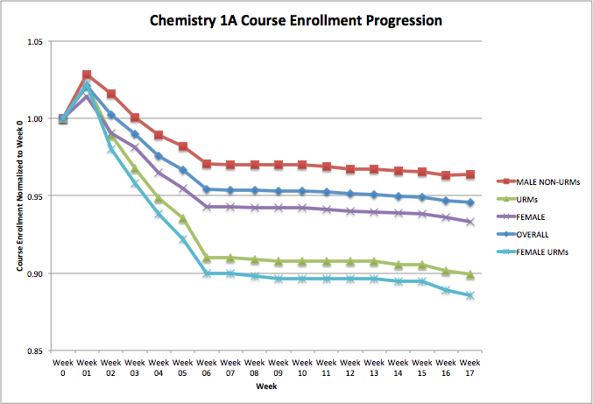Discussion

In our definition of a “weeder course”, we managed to find consistent trends in our data. In our selected weeder courses, the high dropout rates for underrepresented minorities and female underrepresented minorities are consistent throughout our graphs (see data appendix). This common theme in our data further proves that weeder courses results in the lack of diversity in STEM fields. In addition to being in a competitive and difficult course, URMs could face societal and psychological factors that other students that might not apply to them. Some of these factors are further discussed in part 2, the qualitative part of our research.

Results

From our graphs (see data appendix), we found a correlation between higher dropout rates in weeder courses and underrepresented minorities. The gradients in dropout rate for weeder courses are much steeper than in our control courses. In contrast to our weeder courses, in which male non-URMs consistently rank high on the normalized scale, they drop the most in E 7 and IAS 45. From the data given, we made analysis on dropout rates and now have substantial evidence to support our thesis.

**Part 2**

The second part of our research project was primarily focused on finding qualitative reasoning for the trends that we observed through our data analyses. As mentioned in Part 1’s discussion, our results highlight a big disproportionately in dropout rates for URMs, specifically for female URMs. We therefore wanted to understand some of the potential factors that may have been contributing to this.

Method

We decided to use the snowball interviewing methodology, whereby we started out interviewing primarily URM but also non-URM students who had enrolled in identified weeder courses, and then asked them for referrals to other students they may know. A total of 6 students and a professor teaching a ‘weeder course’ were interviewed. The students identified themselves in the following ways:

1. African-American Male, enrolled and completed Chem 1A and Physics 8A
2. Chicano Female, dropped out of Chem 1A
3. African-American Male, dropped out of Physics 8A
4. African-American Female, dropped out of Bio 1A
5. Non-URM Male, enrolled and completed Chem 1A
6. Non-URM Female, dropped out of CS 61A

The interviews were all carried out in person. There were guideline questions for interviewers to follow, but all interviews were done in a fluid format based on the interviewee’s answers.

Results

These common themes came out from our student interviews:

1. The innate difference in background and resources
   1. Well-off background of majority groups vs. underprivileged background of minority groups, and the lack of support for the latter especially in STEM courses
2. Lack of representation for minorities
   1. Includes both being unaware of the other fellow minority groups present in the class, and simply not having enough minorities in STEM courses
   2. According to a recent Daily Californian article, “UC Berkeley’s faculty diversity falls well behind the relative diversity of California’s population, and recent campus reports show that it also lags behind diversity in the academic job market.”
3. Sheer difficulty of the course
   1. Dropouts not only due to midterm scores, but also the speed and quantity of content covered in introductory STEM courses
   2. Traditional lecture courses are typically packed in content and are not intended to actively engage students

From the results, it appears that the adverse effects of chemistry courses experienced by many of the URM students leads directly to these students questioning their own ability to continue to pursue a medical career, and as a consequence dropping medicine as a possible career trajectory (The Turning Point) .

We also noticed that male URMs versus female URMs opinions differed greatly. Female URMs were more likely to talk about lack of “empowerment” and “representation” in the weeder courses they took, while male URMs and non-URMs focused primarily on time management and exploring different options, not necessarily experiencing difficulty in terms of support groups or representation.

The professor teaching a “weeder course” made the following observations:

1. Weeder courses must have the intent of weeding out students, otherwise they should just be considered hard classes with challenging course material.
2. URM students do not utilize resources such as office hours and student learning center
   1. The professor hypothesized that this may primarily be due to high school experiences - URMs may have attended high schools with little resources and may therefore not have the experience and confidence to utilize resources available to them in college.
3. Students are used to getting As in high school and may therefore be dropping out as they consider Bs and Cs to be bad grades, when in fact they should be considered very respectable grades at Berkeley.
4. Although the gender of course GSIs is representative of students, they are very rarely URM GSIs.

Discussion

Several possible band-aid solutions emerged from our interviews:

1. Mini-introductory STEM courses
   1. Especially for those coming from an under-educated background who have had little or no exposure to the difficulty of introductory STEM courses at Berkeley
   2. Example: Chemistry P offered by the Student Learning Center (SLC)
2. A well-developed resource on finding fellow URMs in STEM courses
   1. Mentors who have already took the course, fellow students in the course, etc
3. Ability test in weeder courses to assign discussion sections
4. Increased diversity amongst GSIs / course TAs

The combination of these solutions led us to ask ourselves the following questions:

* Are these resources / solutions already available? Are they publicized and made aware of to URMs? Why do we constantly see this problem of “lack of resources”?
* Are the problems minorities face with STEM courses attributed to their predisposed backgrounds, lack of support from the University, or both?
* There are a few programs targeted toward minority students, but to what extent are they effective? How can we scale them?

Conclusion

In conclusion, our data analysis demonstrated the disproportion of retention rates in individual STEM courses and STEM major course progressions. Female URMs suffered the greatest dropout rates, while Male non-URMs had the lowest dropout rates. This trend was consistent throughout the biggest “weeder courses” at UC Berkeley - Biology 1A, Chemistry 1A, Computer Science 61A and Physics 8A. We led in-person snowball interviews with students from a variety of demographic groups and a professor of a “weeder course” in order to gain a qualitative understanding of the reasons or factors behind this trend. Next steps may entail experimenting potential solutions provided in this paper and delving further into where exactly lies the problem: awareness, support or initiative?

Data Appendix

|  |  |
| --- | --- |
| ‘Weeder’ Courses | |
| Biology Series | Biology 1A | 1B (BIO) |
| Although both under the name “General Biology,” the topics in these classes are unrelated and this series does not need to be taken in order. Bio 1A is known to be harder, covers molecular biology, and has a prerequisite of Chem 1A, while Bio 1B covers ecology and has no prerequisites. Typically, only biological science majors need to take both classes. Other majors require one, but not the other (for example, Bioengineering requires 1A, but the Environmental Earth Science major requires 1B).  Note: We only analyze data for Biology 1A. |
| Chemistry Series | Chemistry 1A → 3A → 3B (CHEM) |
| Chem 1A is general chemistry, Chem 3A is an introduction to organic chemistry, and Chem 3B its continuation. Most College of Engineering students only need to take Chem 1A. The whole series is required by biological sciences majors (in College of Engineering (CoE), College of Natural Resources, or L&S Molecular and Cell Biology/Integrated Biology, students in the Pre-Med track, etc). |
| Computer Science Series | Computer Science 61A → 61B → 61C (CS) |
| The 61 series is required for L&S Computer Science and CoE Electrical Engineering and Computer Science (EECS). In addition, some CoE and Cognitive Science majors can choose to replace their Engineering 7 requirement with 61A. Although this series is for CS majors, 61A and the CS minor has been growing in popularity because of its applicability in other fields. 61A is a time-intensive introductory course, so many non-majors opt for/begin with CS 10, which covers history, social implications, and principles of computing. Many Non-EECS Engineering majors take Engineering 7 (listed below). |
| Physics Series | Physics 8A → 8B (PHYSICS) |
| This series is an introductory physics course and is less calculus-intensive than Physics 7A → 7B (which is “Physics for Scientists and Engineers,” and includes College of Engineering students and L&S Physics students). Physics 8A is a prerequisite for many biological science, architecture, and physical science majors. |

|  |  |
| --- | --- |
| ‘Non-Weeder’ Courses | |
| Engineering Classes | Engineering 7 (E) |
| Except for EECS majors, E7 is required for all College of Engineering majors. It can be taken instead of CS 61A for Cognitive Science and some CoE majors. It covers the elements of programming using MATLAB, a programming language intended for numerical computing. |
| Engineering 25 (E) |
| Engineering 25, or Visualization for Design, is part one of a three-part series required for Mechanical Engineering majors. This three-part series is fairly new (Fall 2014) and is intended to replace the two-part series consisting of E10 and E28. |
| Other Control Classes | International & Area Studies 45 (IAS) |
| IAS 45, or Survey of World History, is reading-intensive class that fulfills the L&S International and Area Studies requirement; however, it is typically taken by prospective Political Economy and Development Studies majors. For the Political Economy major, must be completed with a B- or higher on the 1st attempt. |

Chemistry Series



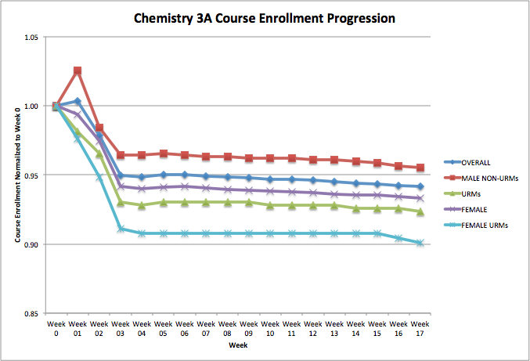

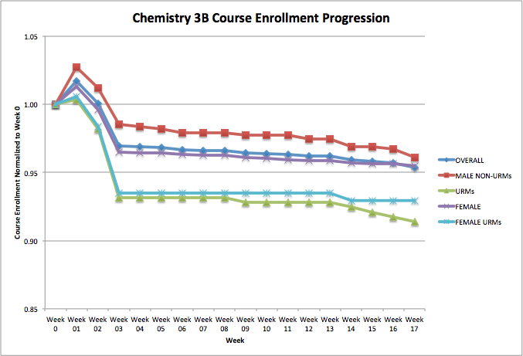

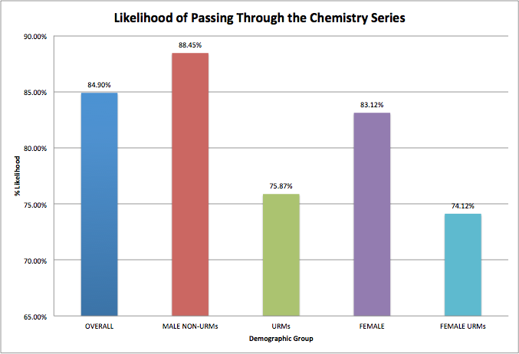

Computer Science Series

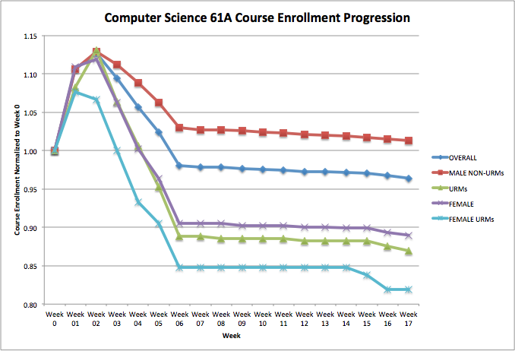

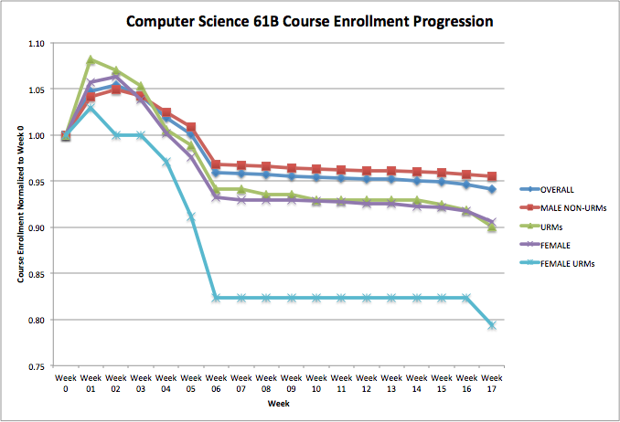

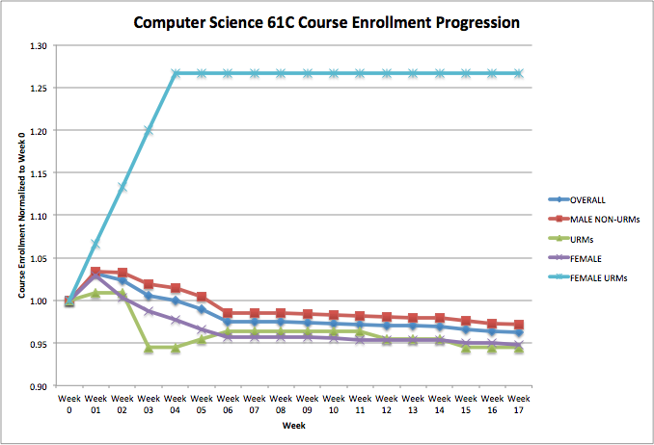

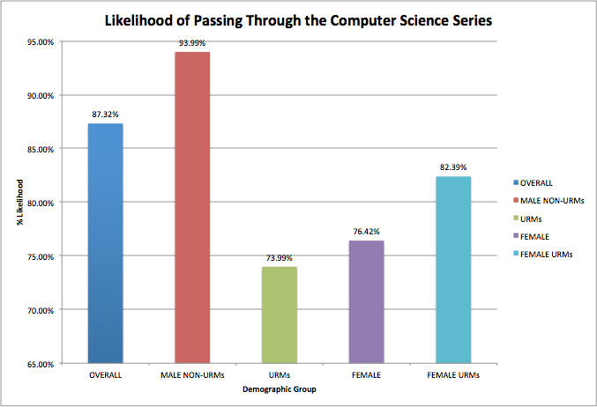

Physics Series

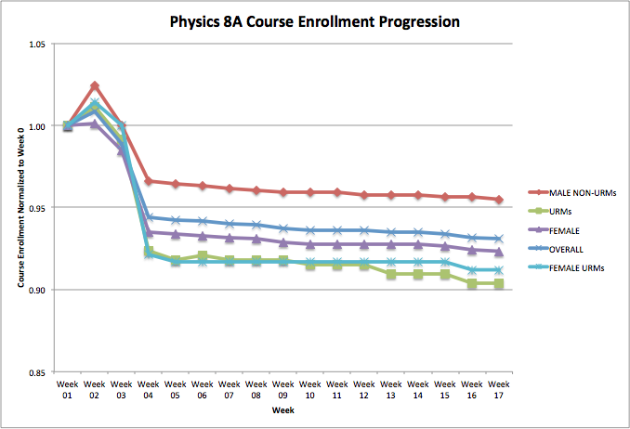

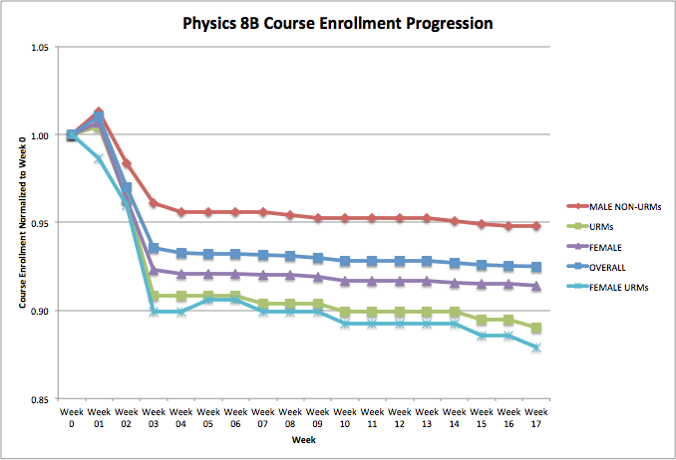

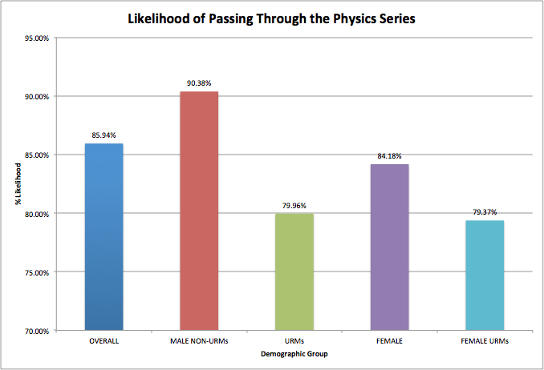

Bio 1A

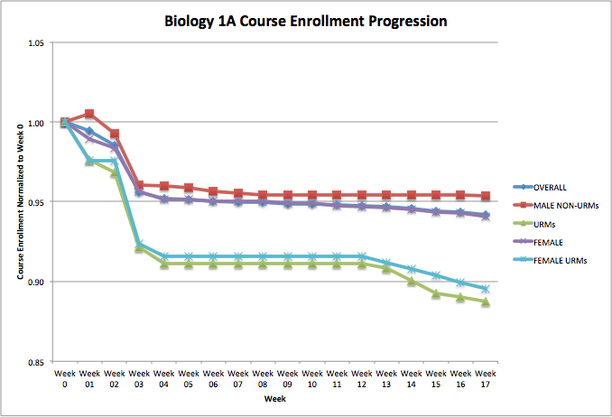

Control: Non Weeder Courses Engineering 7 & IAS 45

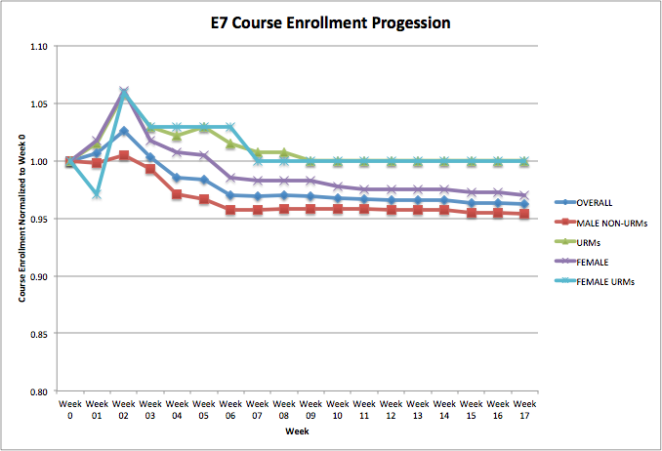

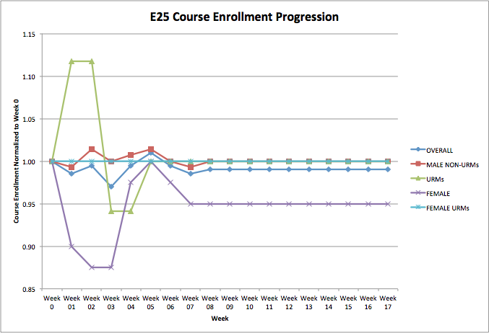

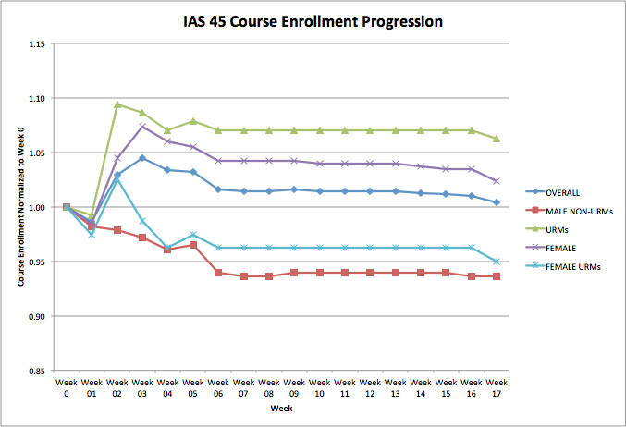

Citations

Barr, Don, and John Matsui. "The" Turning Point" for Minority Pre-Meds: The Effect of Early

Undergraduate Experience in the Sciences on Aspirations to Enter Medical School of Minority Students at UC Berkeley and Stanford University." (2008).

Chang, M. J., Sharkness, J., Hurtado, S., & Newman, C. B. (2014). What matters in college for

retaining aspiring scientists and engineers from underrepresented racial groups. Journal Of Research In Science Teaching, 51(5), 555-580. doi:10.1002/tea.21146

Olson, S., Riordan, D. G., & Executive Office of the, P. (2012). Engage to Excel: Producing One

Million Additional College Graduates with Degrees in Science, Technology, Engineering, and Mathematics. Report to the President.*Executive Office Of The President*,

Pauker, Madeleine. "UC Berkeley’s persistent lack of faculty diversity prompts efforts to address

issue." The Daily Californian. The Independent Berkeley Student Publishing Co., 12 Jul. 2015. Web. 28 Nov. 2015.